Question:

1. Find out MVC pattern for web development

Solution:

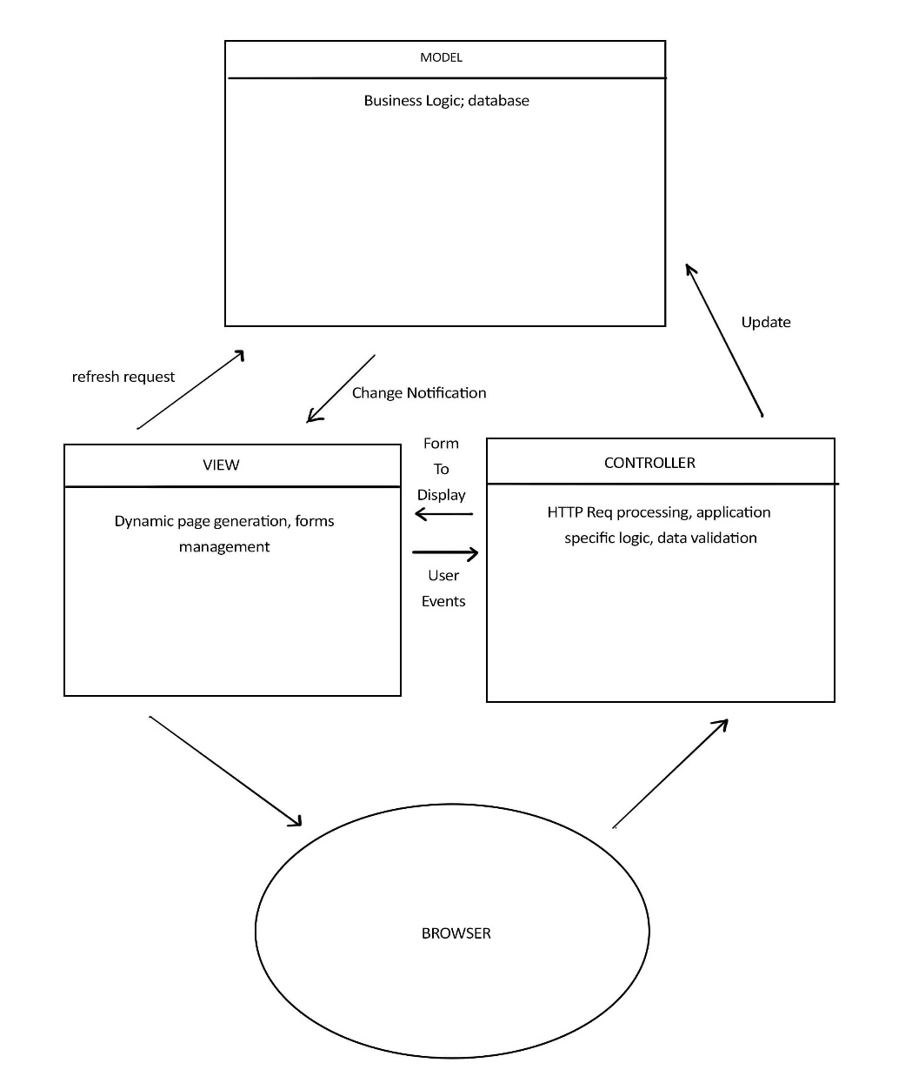

1. Develop and architectural design for student building access

Solution:

For the project, we have chosen the layered architecture

